|  |
| --- |
| **Other Perspective An escape room from another point of view** |

**Created by:**

**Rune Søvsø Christensen (286333) Peipei Su (266128)**

** **

**Simon Bech Jensen (285052) Daniela Koch (266502)**

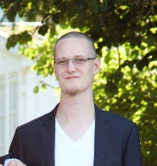 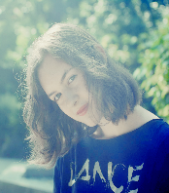

**Michal Jurewicz (266892)**

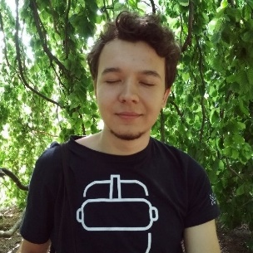

**Supervisor:**

**Kasper Holm Bonde Christiansen**

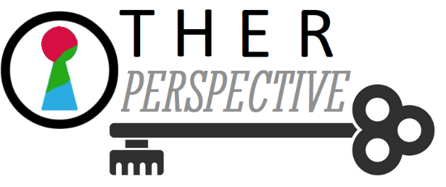

**Number of characters: 39.040**

**Software Engineering**

**4th semester**

**14.06.2019**

I hereby declare that my project group and I prepared this project and that all sources of information have been duly acknowledged.

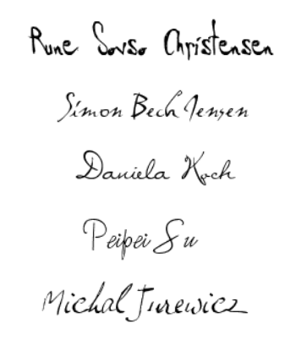

**Table of content**

Abstract v

1 Introduction 1

2 Requirements 3

2.1 Functional Requirements 3

2.2 Non-Functional Requirements 4

3 Analysis 5

3.1 Use case diagram 6

3.2 Use case description - teleportation 6

3.3 Competitor analysis 7

3.3.1 Direct competitor 7

3.3.2 Indirect competitor 9

3.3.3 “Other Perspective” - our VR experience – comparison 11

3.4 Activity Diagram 12

4 Design 15

4.1 Interactions 15

4.2 System architecture 15

4.3 Level Design 16

5 Implementation 18

5.1 Colour-blindness 18

5.2 Parkinson’s disease 20

5.3 Bad vision 22

6 Test 24

6.1 Test Specifications 24

6.1.1 Use cases tests 24

6.1.1 Puzzles tests 26

7 Results and Discussion 28

7.1 Results 28

7.2 Discussion 29

8 Conclusions 30

9 Project future 31

9.1 Target group 31

9.2 Future development 31

10 Sources of information 33

11 Appendices 1

**List of figures and tables**

Figure 1 - An example plan of an escape room 2

Figure 2 - HTC Vive - a VR tool choosen for the project 4

Figure 3 - Use case diagram 6

Figure 4 - A screenshot from "Belko VR" 7

Figure 5 - A screenshot from "Accounting" 9

Figure 6 - Activity diagram 12

Figure 7 - The scene seen from above in Unity 16

Figure 8 - The old warehouse scene in Unity 17

Figure 9 - The outdoors part of the scene in Unity 17

Figure 10 - Colour-changing glasses 18

Figure 11 - Colour-blindness types 18

Figure 12 - Colour-blindness script – applying shaders 19

Figure 13 - Hands shaking script - choosing new direction 20

Figure 14 – Hands shaking script – coroutine and causing vibrations 21

Figure 15 - Post-processing example in Unity 22

Figure 16 - Bad vision handling 23

Figure 17 - Unified process and its phases 30

Figure 18 - Phobias - one of potential disorders to be added 32

# Abstract

In today’s world everybody is different from each other and these differences depend on many factors, as race, nationality or even gender. This brings about that every human has their own mindset and perspective which can differ absolutely compared to others’.

Besides considerations mentioned above, there are also many issues that cause the viewpoint of given person to be literally different and impossible to understand from the outside. These so-called perception disorders wield influence on a person making them perceive the world unlike anybody else. In order to let others understand this, there are already many books written about these topics, many information can be also found in media as well but it can be not enough to give a possibility to imagine it fully.

In order to do so, VR technologies can be used. The system that is object of given report is a puzzle game made in escape room style, where both colour-blindness and Parkinson’s disease are used as necessary means of completing tasks. This way, the users can get a truly immersive view that puts them in the shoes of a person with given disorder. And what is important, there is a story behind everything, which makes this experience unique and more appealing to the player.

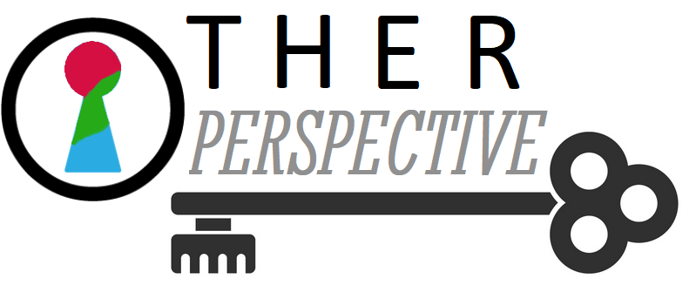

# Introduction

The initial idea of the project was an application enabling people to experience mental disorders. Specifically, to give these who work with people suffering from them a first-person experience of their day to day challenges. That would allow the user to understand both the disease and the person suffering from it and as a result, be able to provide help on a higher level.

During the first stage, a number of mental diseases and perception disorders were researched, such as Schizophrenia, depression, phobias, Parkinson’s disease, colour-blindness, bad vision and migraine. Each disorder had its characteristics distinguished and the way of how it could be shown together with an appropriate technology assigned, choosing between Augmented Reality (AR), Virtual Reality (VR), Mixed Reality (MR) and the Teslasuit. The group established contact with Dr. Robert Pind from a pain clinic in order to get first-hand information. The main focus was Parkinson’s disease with the use of Teslasuit. There were two leading ideas. The first one concerned the usage of the Teslasuit as a mean in rehabilitation, while the second one giving the Parkinson’s disease experience to the psychiatrists, caretakers. The dialog lasted for about two weeks. However, Dr. Robert Pind did not see a realistic scenario for implementing the Teslasuit in his clinic, as the field is too heavily influenced by placebo, up to 60% suffering from Parkinson’s disease is experiencing placebo according to Robert.

Eventually, three perception disorders were chosen to work with for the project: Parkinson’s disease, colour-blindness and bad vision. The reason behind choosing them was that they were the ones that could be presented the most accurately and would not be too hard to implement. The technology selected was VR. The choice was based on the immersive experience VR offers, as well as the feeling of presence, that would provide a real-life experience, leading to an actual true understanding of the disorder. [*(Reference)*](https://www.youtube.com/watch?v=eFHj8OVC1_s&fbclid=IwAR2D5lCkS7Up1mBXoQzdzQ6lWqZR3X_kvDCO4jcMcWS6BGDrzNa6iwrcP5g)

As the chosen disorders were connected more with perception than mental health, at that point the purpose of the project had to be re-evaluated. The new goal was to, first of all, increase understanding between people that perceive the world differently and, moreover, to raise awareness about these disorders and the fact that everyone is different and unique. And lastly, another purpose was to give the possibility to satisfy one’s curiosity regarding how it is to be colour-blind, suffer from bad vision or have Parkinson’s disease.

Due to changing the scope of the project, the way of implementing it also had to be different. Originally, the idea was to have separate rooms for activities connected with specific disorders. Having the purpose of the project adjusted, a new requirement came into sight. Bearing in mind that the new purpose was to understand, raise awareness and satisfy curiosity, the application had to attract as many people as possible, not only with its functionality but also by being entertaining.

In order to make the experience more entertaining and attractive, it was decided to convert it into an escape room. “Escape rooms are adventure games in which teams of friends, family or colleagues work together to find clues and solve puzzles to escape a simulated danger before time runs out.” [*(Reference)*](https://www.nytimes.com/2018/04/11/business/escape-room-small-business.html) However, VR escape rooms are usually individual experiences. [*(Reference)*](https://www.nytimes.com/2018/04/11/business/escape-room-small-business.html)

Gamification is not the only factor that attracts people to choose this form of entertainment, another one is the challenge. As a proof, in only 4 years the number of escape rooms in America has raised from 22 to 2000.

To sum up, presented project is a VR escape room that increases understanding between people that perceive the world differently, raises awareness about colour-blindness, bad vision and Parkinson’s disease and the fact that everyone is different and unique, as well as satisfies one’s curiosity regarding how it is to have these disorders.

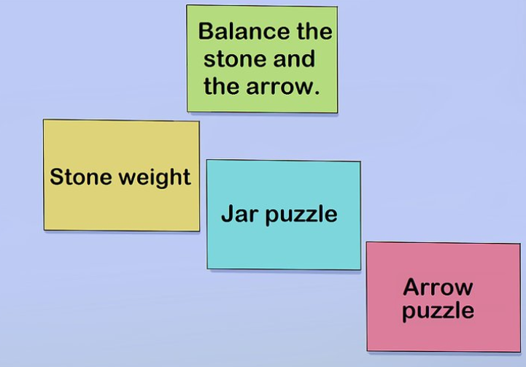

Figure 1 - An example plan of an escape room

# Requirements

In order to have all the ideas about how the final product should look like and to know all its functions, a list of requirements was created. First, there are the ones related to functionality, after which the rest explains non-functional matters.

## Functional Requirements

1. The system needs to simulate at least three disorders: colour-blindness, bad vision and Parkinson’s disorder.
2. Colour-blindness:
   1. The system has to be able to show different types of colour-blindness.
   2. The user has to be able to perform tasks relating to colour-blindness.
   3. The system has to interpret the light wave spectrum.
   4. The system has to include light wavelength changing mechanism.
3. Bad Vision:
   1. The system has to be able to simulate bad vision (adjust the visibility of objects depending on their distance from the user).
   2. The user has to be able to perform tasks assigned to bad vision.
   3. The system has to have blurring vision mechanism.
4. Parkinson’s disorder:
   1. The system has to be able to simulate Parkinson’s.
   2. The user has to be able to perform tasks assigned to Parkinson’s disorder.
   3. The system has to include shaking controller mechanism.
5. The system needs to include a few puzzles connected in a logical way.
6. The user needs to be able to interact with objects in the scene(s).
7. The system needs to include some kind of locomotion.
8. For each disorder, the system could allow the player to test a given task with the disorder turned off for comparison.
9. The system could include a tutorial for each disorder.
10. The system could allow the player to learn more about each disorder.
11. The system could contain more disorders.

## Non-Functional Requirements

1. The system needs to be implemented using Unity framework.
2. The system needs to have scripting in C#.
3. The system needs to be created in Virtual Reality.
4. The system needs to be built on Oculus or HTC Vive.
5. The system needs to be documented in a project report.

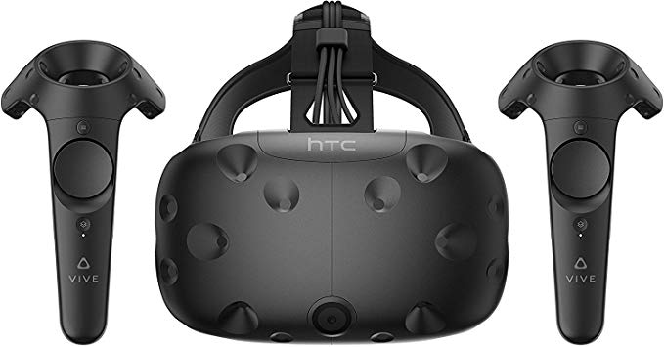

Figure 2 - HTC Vive - a VR tool chosen for the project

# Analysis

As mentioned before, “Other Perspective” was decided to have 3 kinds of disorders simulated, which are: bad vision, colour-blindness and Parkinson’s disease. For implementation, all three technologies were considered: AR, MR and VR. As the experience was supposed to be as real and immersive as possible, AR was excluded. Both technologies left had their pros and cons.

MR offered the opportunity to express the real world with a given disorder. To give an example, the user could see their own house the same way as someone with colour-blindness or bad vision. That seemed as what the purpose of the project was. However, simulating Parkinson’s disease in MR would be a bigger struggle, as the user can see their own hands that are not shaking, in fact. Moreover, another drawback is the field of view in MR. The display is a holographic overlay over the real world, which does not cover the full field of view. That unfortunately breaks the immersion of the experience. [*(Reference #1)*](https://www.microsoft.com/en-us/p/microsoft-hololens-development-edition/8xf18pqz17ts?activetab=pivot:techspecstab) [*(Reference #2)*](https://mashable.com/2018/05/08/microsoft-hololens-field-of-view-big-weakness/?europe=true)

On the other hand, as mentioned in the introduction, VR offers a fully immersive experience. Even though colour-blindness and bad vision are not be overlaid on the real world, due to the immersion and feeling of presence, it would still feel real for the user. What is more, the two considered headsets: HTC Vive and Oculus Rift come with controllers, which can simulate shaking. [*(Reference #1)*](https://www.vive.com/us/comparison/)[*(Reference #2)*](https://www.oculus.com/rift-s/)

Bearing all that was said in mind, the technology chosen was VR. The next big decision ahead was the choice of hardware. As declared previously, the two available and considered hardware were HTC Vive and Oculus Rift.

By comparing hardware specifications, it could be defined easily that HTC Vive has better display size, refresh rate, field of view and controller support standard than Oculus Rift. [*(Reference)*](https://dgit.com/oculus-rift-vs-htc-vive-61022/) Therefore, HTC Vive was chosen for being the development hardware for this project.

## Use case diagram

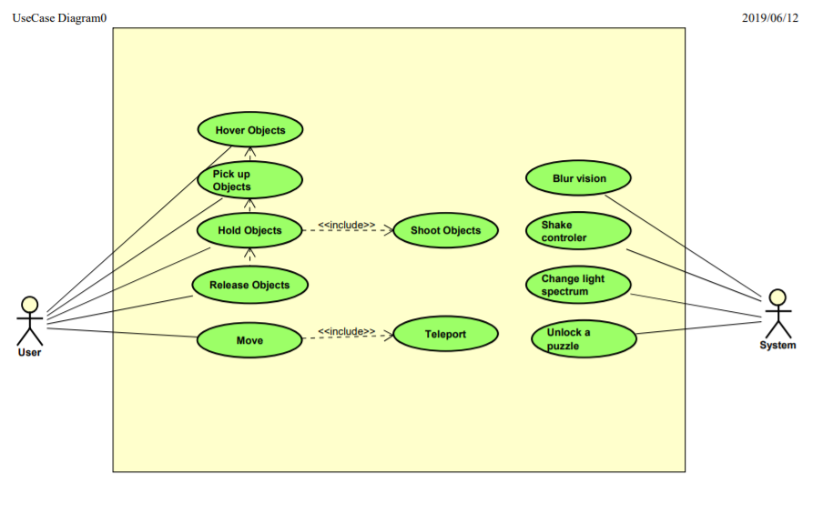

Figure 3 - Use case diagram

The use case diagram visible above shows all possible actions that users and the system can do. The user can perform simple interactions with objects, which depend on each other, and move. The system simulates disorders by blurring vision, shaking controllers and changing the light spectrum. Furthermore, it unlocks puzzles.

## Use case description - teleportation

**Actor:** User

**Preconditions:** the user runs the game with controllers connected to the computer.

**Base sequence:**

1.User clicks on the touchpad.

2.User chooses a position to move to with the use of a pointer mapped at the floor.

3.User gets moved to the chosen position.

**Exception sequence:**

If the chosen position has colliders, user has to choose an available position (the pointer being green for available positions and red for not available).

If the chosen position exceeds the teleport ground, user has to choose a valid position (the pointer being green for valid positions and yellow for not valid).

## Competitor analysis

### Direct competitor

**“Belko VR” – escape room**

In this single player virtual escape room based on the 2016 movie "The Belko Experiment", the player has to solve puzzles in order to avoid having a microchip in their brain explode while listening to their co-worker on the phone. The game is meant to make the player ask themselves "What does it take to survive at work?".

Released on the 3rd of March 2017 by the company Top Right Corner in association with Yarvo Productions and Paper Crane Productions. “Belko VR” requires either HTC Vive or Oculus Rift and is best experienced in a standing environment.

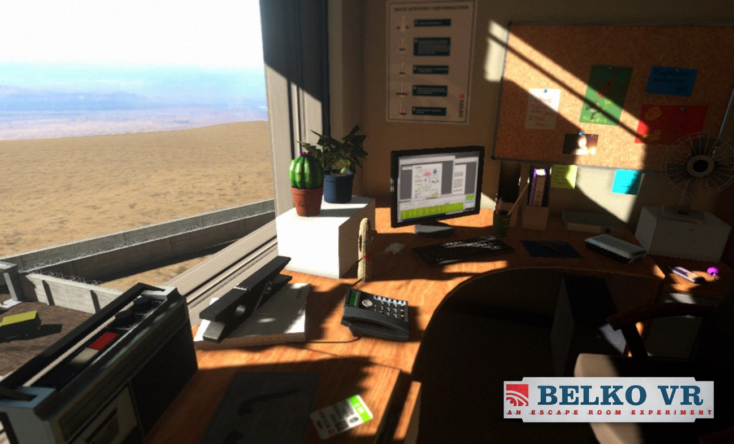

Figure 4 - A screenshot from "Belko VR"

**Price:**  Free

**User demographic:**Since the game is free and does not have an age constriction, the user demographic can be estimated to be quite large and have minimal constrictions, although the game does feature an exploding head which can limit the age of the target demographic.

**Reviews:**  “Belko VR” has almost entirely received positive reviews on steam with a few that are unhappy, either because of their own setup or just general frustration over mechanics.

**Product features: “**Belko VR” is primarily a single scene exploratory experience where the player gets to interact with all items necessary to complete the puzzles from the start. The game utilizes simple interactions as teleportation and holding things. Other features include animations, voice acting and lasers!

Belko also uses regular items as part of their puzzles like the almost out of place weight scale, or a special flashlight found during the game.

**Visual design: “**Belko VR” uses a single scene reminiscent of that of an office space, as in the movie. They use bright colours and outside it is a sunny and clear sky. At first look, there is nothing that suggests that the player is in any form of danger, which the visual design conveys in a pleasant way and works well for the immersion of the game.  Overall, the visual design is very formal and on point to set the user up for an immersive experience.

**Overall language:** The language is very formal. There are auditory clues throughout the game in a mild and friendly voice/tone. Overall the player only talks to one person, a friendly co-worker.

**The team’s thoughts:** It was agreed that the escape room was pretty good, considering that it is free. The puzzles were well thought but felt rushed towards the end and most of the time spent on the game was during the tedious laser wall which was more annoying than anything else.

The games locomotion was an insight into how to combat a potential player limited play area by using teleportation, which allows the player to be stationary. In general, the controls worked really well with some minor collider issues that could provoke some motion sickness.

The locomotion in the game tends to make the user a little anxious since the player has to actually move their body inside every scene which invites for collision with the real world. Said collision can be immersion breaking.

### Indirect competitor

**“Accounting - VR escape” (Legacy)**

“Accounting” explores the honourable profession of crunching numbers as an accountant, or so it says. In this game the player has to solve a puzzle in different settings. The player explores different realities with voice acting by Justin Roiland himself, the voice of Rick Sanchez in the hit tv show "Rick and Morty".

The game relies heavily on humour, which is conveyed in a very “Rick and Morty” way, very stressful or in a paced manner, depending on a person.

Published on 18th of October by the company Crows Crows Crows and developed by the same along with Squanch Games. “Accounting” was made for HTC Vive and requires a 2m x 1,5m play area as the game tracks the players position rather than utilizes regular locomotion like teleportation.

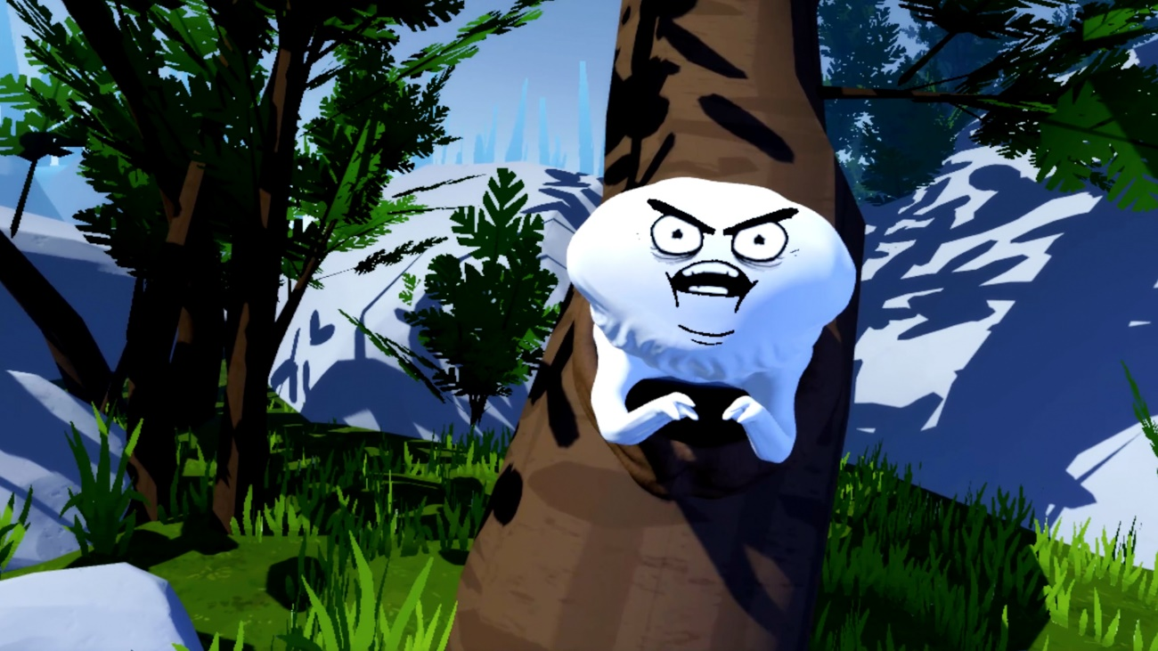

Figure 5 - A screenshot from "Accounting"

**Price:** Free

**User Demographic:** Despites the name of the game, “Accounting” is like “Belko VR” limited by its graphical content which should not be viewed by children of all ages, as they say themselves: "Content warning: cartoon violence, gore, suicide, tax work." Because of its graphical language and harassing monologue, the game might appeal more to a younger crowd who is familiar with “Rick and Morty”.

**Reviews: “**Accounting” has received 95% positive remarks on steam with minimal complaints, most of which are generally just not fans of the audio cues.

**Product features: “**Accounting” is a multi-scene linear experience where the player is never overwhelmed with different choices, just voices. The game features very limited actions in the form of grabbing a very limited number of things. It has multiple scenes with their own separate design, giving the feeling of traversing other dimensions which are entered through the power of VR goggles that are unlocked when completing the puzzle of the scene. There are more items in some of the scenes that the player can interact with, like a xylophone found in the King of VR's stomach. Yes, stomach.

As said before, the game features known voice actor and co-creator of Rick and Morty, Justin Roiland, which most younger people can relate to and therefore encourages the player to either have fun or hate it because of it.

**Visual Design: “**Accounting” has a very cartoony feel to it with bright colours and assets that look homemade. The introduction to the game is very formal compared to the rest of the game and is the last place the player feels connected to the real world. This symbolizes the leap into VR where things can get pretty crazy pretty fast.

**Overall language:** The overall language of the game is offensive and most that have seen play the game felt assaulted, but they also had a tendency to be smiling, so it is a very hate it or love it mechanic. “Accounting” also utilizes the speech pattern found in Rick and Morty with a lot of stuttering and annoyance towards incorrect actions.

**The team's thoughts: “**Accounting” was a pretty fun experience, which could be well suited as an intro for new VR players since it has very limited controls and features simple puzzles that are easy to approach if the player has a correctly setup play area.

### “Other Perspective” - our VR experience – comparison

“Other perspective” is an VR escape room with a twist. Can you escape the evil Dr. Doctór PhD's shark tank pitch before his patience runs out? All along enjoying various disorders like colour-blindness, Parkinson's disease or bad vision! Can you shoot the yellow balloon? In “Other Perspective” the player has to rack their brain to find meaning, and answers as to why they are even there in the first place!

**Product features:** From the team’s research, playing games. There were identified some key features that were agreed to be included. The first feature discussed was locomotion where it ended on utilizing teleportation since it tends to be more immersive when the player does mot have to keep track of where they end up in their own play area, as to not destroy the controller against a brick wall suddenly. It was also discussed to make the overall experience having gamification elements as to make it more engaging to learn about the difficulties a person with for example colour-blindness must deal with daily, and present this in a humorous manner that invites to play.

Like “Belko VR” has a mini golf set that has nothing to do with the overall puzzles, this experience should also have interactable items in the scene that the player can get distracted by.

It was not really possible to find any Easter eggs in the other rooms, but “Other Perspective” contains at least one. There is also included a short intro for newer VR users, where they can get some hints as how to interact with items in the scene and use controls.

**Visual design:** The scene in “Other perspective” is 100% homegrown, with standard assets to make it all come more to life. The scene is set in a dark warehouse looking building with sound hinting of a waterfront nearby.

**Language:** From playing games like “Accounting”, it was agreed on that humour tends to have a good response with players and therefore the aim is to make the dialogue in the experience to be humorous with minimal or none hints.

The main protagonist is in a GLaDOS, from the game Portal, style “helper” which will at certain times hint at where the next clue is or where the player must look.

## Activity Diagram

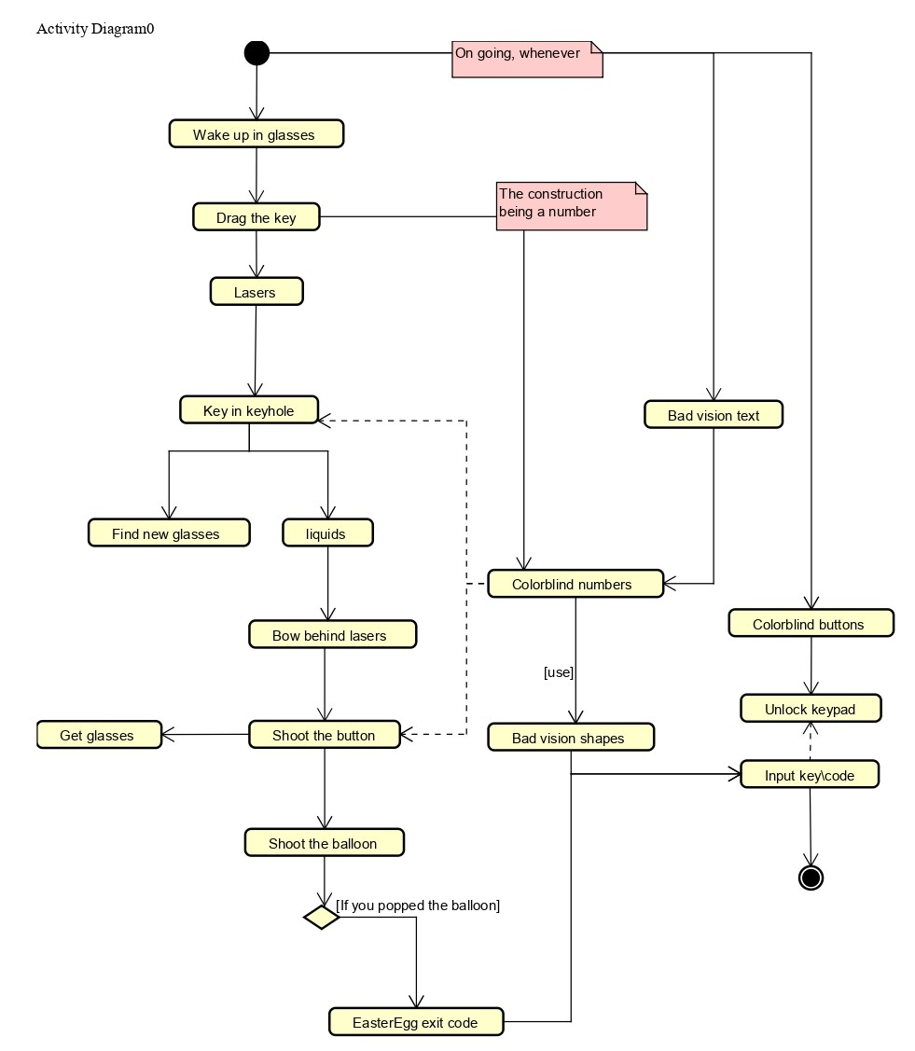

Figure 6 - Activity diagram

The above diagram presents the main flow of the game. The flow of the escape room is thought to be a mix between the exploratory approach, where the user is left to find all the clues on their own and can do the puzzles in their own order and the linear approach, where the user is forced to take the predesigned path of puzzles. This is why there are some side branches labelled “Ongoing, whenever”, what implies that the puzzles are ongoing and the user can approach them at any point of the game.

The main flow starts with the player waking up in glasses that are causing colour-blindness. The first puzzle the user is encouraged to go to is the “Drag the key” puzzle. Just as the two following tasks, it involves Parkinson’s disease. In this exercise, the user has a key which they have to drag on a thin wire without touching it. If the player touches the wire, they have to take it back to the beginning and start over.

Once the key has been released from the wire, the player has to put it all the way through lasers. This puzzle has been inspired by the “Belko VR” escape room. In “Belko VR”, there is a wall of lasers with a laser-free square, through which the user has to drag a cube. In this project’s case the cube is a key and, additionally, the hand holding the key is shaking.

Having put the key through the lasers, it is time to put it in a keyhole. Sounds easy, unless the player suffers from Parkinson’s disease.

Once the player gets rid of the key, their hands stop shaking. Moreover, the key unlocks a liquor cabinet. Besides the liquids, the cabinet also contains a pair of glasses with a new shade of colour-blindness. The liquids puzzle requires the user to mix fluids with different colours in order to get the desired one.

The perfect drink unlocks an access to bow, that has to be accessed through a wall of lasers (the same concept as with the key). The bow is needed to shoot a button through a window. The button triggers two events: reveals the last pair of glasses and releases a balloon. If the player reacts quickly and shoots accurately, they can pop the balloon and be rewarded with an Easter egg with the exit code.

As mentioned before, next to the main flow, there is a number of ongoing puzzles. One of them is called “Colour-blind buttons”. The task is to press buttons with different colours in the correct order. However, it is not possible to see everything coloured properly at once. That is why to complete this puzzle, the user needs all glasses, which can be accessed after completing all puzzles from the main flow. Once the buttons have been pressed in the correct order, a keypad is unlocked. If the user has gotten the Easter egg, they can now input the exit code and end the game.

Another ongoing puzzle is “Bad vision text”. Primarily, the text is too blurry to be read. However, each pair of glasses makes the text sharper and eventually the player is able to read the text.

The message involves a number. The wire from the first puzzle is in the shape of a number and the keyhole and button have numbers from colour-blind tests next to them. All of those have to be used in a task called “Bad vision shapes”. As the name suggests, it involves bad vision and shapes - shapes that are blurred. The models are next to the keypad unlocked with the sequence buttons. At this point the player has to realize that each of the shapes represents one of the prior mentioned puzzles and those puzzles involve numbers. The numbers need to be input in the keypad in the correct order. Once it has been done, the game ends.

Besides, all the time there is a clock measuring the time. If the time limit passes, the game ends.

# Design

## Interactions

The use cases presented on Figure 1 clearly state that a big part of the system is about the user interacting with objects. There are a few approaches to achieve it. In this system’s case it is done with the use of SteamVR Plugin from Unity Asset Store. [*(Reference)*](https://assetstore.unity.com/packages/tools/integration/steamvr-plugin-32647) There is a number of reasons behind this choice.

First of all, SteamVR Plugin is universal and works with all popular PC VR headsets. That means that the final game is not limited to only one specific type of headset but, instead, is commonly accessible for all users with any type of headset.

Another benefit of SteamVR Plugin is handling input from and output to users. The developer does not have to handle it on their own and just has to set up actions and bind them to the desired input on the controllers. The logic behind it is managed by the plugin.

Moreover, the tool provides a collection of ready actions to use with simple to understand examples, including grabbing and throwing objects and different types of locomotion.

Additionally, it is quite easy to find ready models for controllers and hands that can easily be used in one’s own project.

## System architecture

The whole game flow consists of puzzles and the way they are connected together. In order to assure that the whole game can be completed, it is necessary to have all the smaller parts working properly. To handle all of them, events were used because doing it this way allows to organize everything in a logical way and be accessed easier.

The place everything is connected to is the game manager. Its purpose is to delegate all events and, what it implies further, handle all the puzzles’ behaviour. That means it is the part of the system responsible for activating and deactivating every of puzzles related assets as well.

Furthermore, thanks to this kind of solution, the system follows the most important ones of SOLID principles, which are the thing that was tried to be achieved throughout all the development process. That means, for instance, that the classes have single responsibilities and the whole game is structured in a loosely coupled way.

## Level Design

Due to the fact that the project is an escape room, the game scene should be somewhat mysterious and strange to the player. From the definition, it also had to be a closed interior. After generating some ideas, it was eventually decided, that the game would take place in an old and abandoned harbour storage building.

The scene consists of a main big hall, which is the play area for all the puzzles and four smaller rooms in the corners. The purpose of these rooms is to store all the puzzles’ elements, so that not everything is in-game at once. Doing so allows to achieve better performance and avoid lags and crashes.

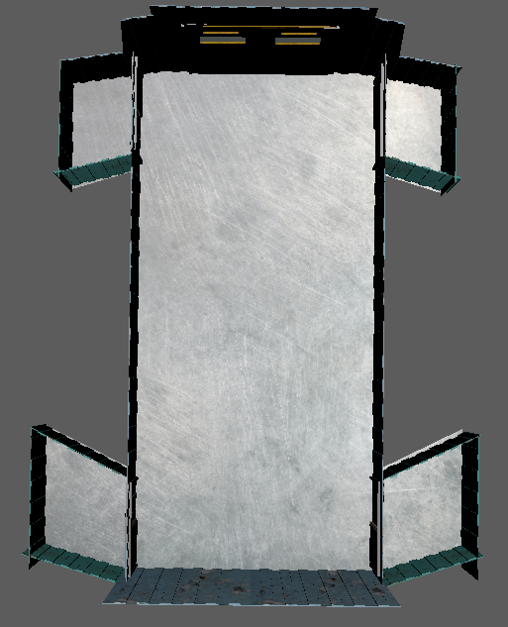

Figure 7 - The scene seen from above in Unity

All the building was created using Autodesk Maya from scratch, so that the whole interior could fit all the needs and look exactly as desired.

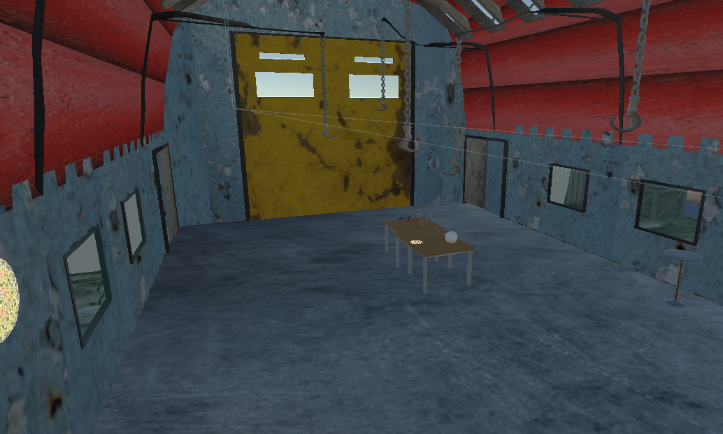

Figure 8 - The old warehouse scene in Unity

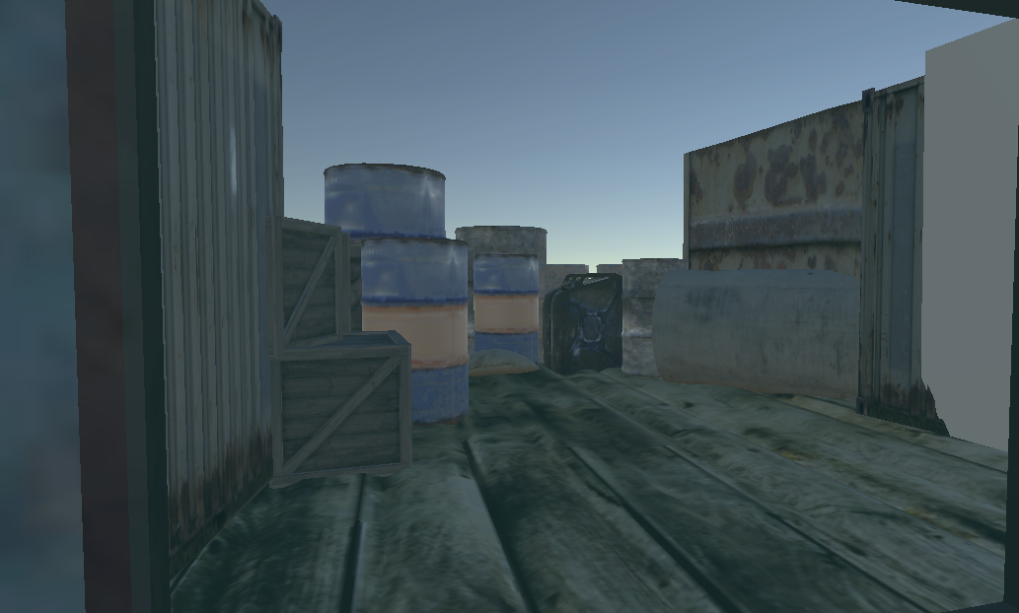

Figure 9 - The outdoors part of the scene in Unity

To create a better immerse of a harbour, when the player comes close enough to the main closed door, they can also hear sounds of a sea. Furthermore, there are also randomly played sounds of, for instance, seagulls and ships. To achieve even better atmosphere, all the playthrough has an ambient soundtrack.

# Implementation

The implementation of the system was done in accordance with the previously set requirements, the analysis and the design of the project. While developing the project, the remaining time was constantly being compared against the benefits of implementing a certain functionality, upgrade or optimization. This section covers essential information regarding the system and highlights the most interesting details.

## Colour-blindness

Due to the fact that it is impossible to manipulate the player’s brain in order to

change the way they perceive the world, the solution to simulating colour-blindness is changing the environment around. This way, it can imitate the world seen by a person suffering from said disorder. In this project’s case, it is done using shaders.

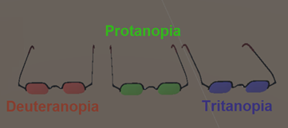

Figure 10 - Colour-changing glasses

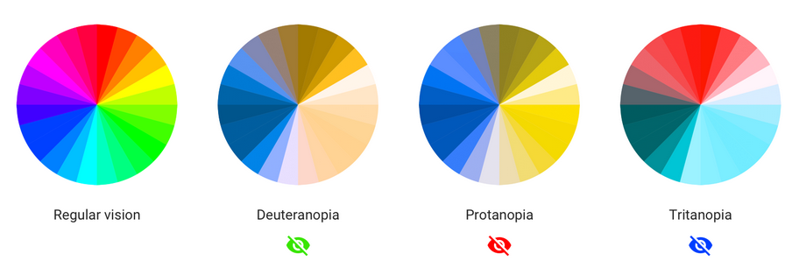

Figure 11 - Colour-blindness types

To begin with, there is needed a way of changing colour palettes that differentiates between them and can be used easily. It was decided that there will be multiple pairs of glasses, one for each type of colour-blindness (there are three major types that are used in-game). Because of lack of appropriate assets, there were used ones that were self-created.

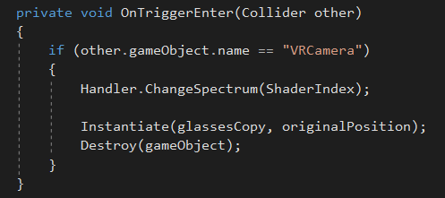

Figure 12 - Colour-blindness script – applying shaders

When it comes to the code, its most important part is the method presented in the figure above. The script is located on just mentioned glasses and whenever there is a trigger detected, the system checks whether the object that caused it is the VRCamera. If that is true, depending on which exact pair was put on, appropriate shaders assigned to it are being applied, resulting in changing the colour spectrum.

In the end, it is assured that the pair of glasses is being re-spawned on its default positions by instantiating a new copy of the object and destroying the one that has been just used. This is done in order to make sure they are always in the same place, so the user cannot lose them.

## Parkinson’s disease

The feeling of Parkinson’s disease should let the player believe that their hands are shaking. Because of the fact it is impossible to provoke said fillips directly, the best way to approach this goal is by making controllers to vibrate. The figure below illustrates how it was done.

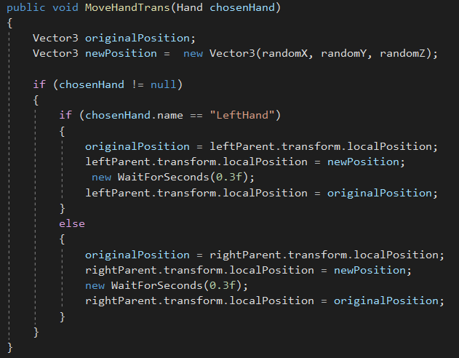

Figure 13 - Hands shaking script - choosing new direction

First of all, there are two crucial variables, one for each hands. In the method shown above, there are two vectors, for one a default position, where the hand is located currently and the second one for a new one. Whenever it is called, it randomly chooses a new position and updates the old one. This action is being done for either left or right hand, depending on the parameter.

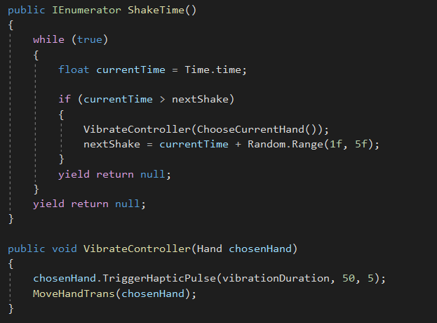

Figure 14 – Hands shaking script – coroutine and causing vibrations

When it comes to controllers’ vibrations, they are set in *VibrateController()* method by using *TriggerHapticPulse()* method, which comes from SteamVR. It takes three arguments: duration of the vibration, frequency and amplitude. Whenever it is called, the player can immediately feel one of their controllers doing tiny random movements which are heavily decreasing precision of their actions.

The heart of this class is *ShakeTime()* coroutine that is called at the beginning and does not end ever. Its purpose is to generate new vibrations and random hand movements. This happens in time intervals that are random as well and can be as short as 1 second and as long as 5 seconds.

## Bad vision

Among all the simulated disorders, bad vision can be considered as the one that is the easiest to understand and imagine by anyone. It is surely the most common disorder in the real world and therefore almost everybody knows a person that suffers from it. It is also the easiest disorder in terms of programming it.

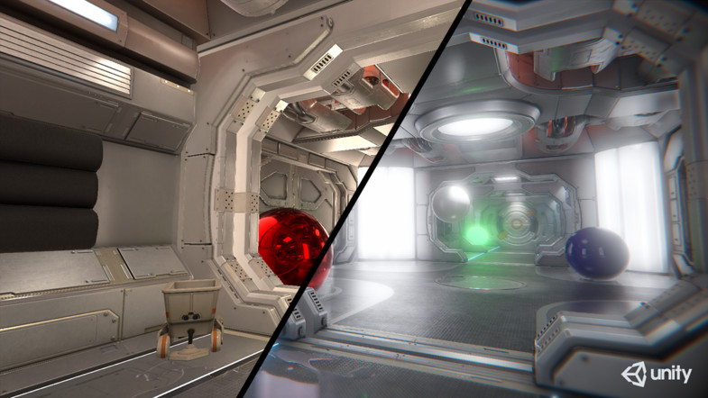

Figure 15 - Post-processing example in Unity

The easiest way to achieve blurred vision in Unity is using so-called post-processing. As it says in the name, it is a process of applying effects and filters to the camera. It allows to create many different ways of perceiving the in-game world, from creating the feeling of an ultimately shiny interior to a dusty one.

In the case of this project, there were used only a few basic processes that result in restricting the player’s field of view. Each of them has a number assigned, so it can be referred to easily.

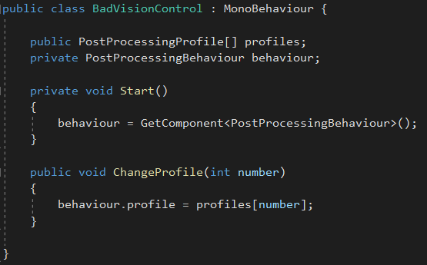

Figure 16 - Bad vision handling

As shown above, the script that is responsible for applying bad vision contains only a few lines of code. The only method other the default ones is *ChangeProfile()*, which takes a number corresponding to a different type of bad vision and applies it to the player.

# Test

## Test Specifications

Each development process requires a testing phase in order to make sure that all the functionality meets the expectations and works properly. This is why there were carried out both use cases and puzzles tests, which assured that none of the system functionality malfunctions and the game flow is not interrupted at any point.

Besides, there was prepared a questionnaire about the whole game and experiences after playing it as well as about the player. Unfortunately, due to lack of time and, what it implies, not having the game fully finished at that point, there are no answers to that. Anyway, it could be used at any point of potential future development in order to get feedback, eliminate bugs if there are any spotted and improve the whole experience.

### Use cases tests

In case of this project, each of the use cases was looked at separately and in connection with all the others. The table below lists these tests and explains how they were handled together with their corresponding results.

|  |  |  |
| --- | --- | --- |
| ***Use Case*** | ***Way of testing*** | ***Result*** |
| Hover objects | Tests consisted on checking if the object that the user is currently touching with a controller is highlighted, notifying that it is hovered. | In the end, any object that is interactive is highlighted when the user touches it. |
| Pick up objects | Tests consisted on checking if the object that is being hovered can be picked up from the ground. | All the interactive objects can be picked up when they are hovered on. |
| Hold objects | Tests consisted on checking if the object that has just been picked up can be hold in hands by the user for any time. | The user can hold any of the interactive objects for any time. |
| Shoot objects | Tests consisted on checking if the user bearing a bow is able to shoot arrows and if the arrows can collide with objects and trigger actions when hitting special targets. | It is possible to bear a bow and shoot it any directions, the arrows have properly working collisions and activate triggers when correctly. |
| Release objects | Tests consisted on checking if the user is able to free their hands and put the object they are holding down. | Any held object can be put down at any point of time. |
| Move | Tests consisted on checking if walking in the real world causes the user moving inside the game. | The user can move in the real world to notify movement inside the game. |
| Teleport | Tests consisted on checking if the user has a possibility to move using a controller in order to teleport to a location. | It is possible to use controller to teleport anywhere inside the special plane layer that is created for this purpose. |
| Blur vision | Tests consisted on checking if the system simulates blurred vision properly, increasing or decreasing the field of view. | The system can change the accuracy the user sees the in-game environment. |
| Shake controller | Tests consisted on checking if the system can make controllers shaking, decreasing the user’s precision. | The system can cause controllers shake in the users’ hands. |
| Change light spectrum | Tests consisted on checking if the system changes the light spectrum appropriately by assigning correct shaders when needed. | The system can make the user see everything in different colour palettes. |
| Unlock a puzzle | Tests consisted on checking if the system keeps track of the user’s progress, meaning it knows which puzzles are locked and unlocked and acknowledges which ones are already completed and with what result. | All the progress done by the user is kept in the system respectively, differentiating locked and unlocked puzzles. |

### Puzzles tests

The same thing applies to puzzles, which can be considered as building blocks of the whole game. It was therefore crucial to make sure that all of them work and the game flow is working properly. The table below lists all the puzzles with their flow and all the possible scenarios the player can go through.

|  |  |  |
| --- | --- | --- |
| ***Puzzle*** | ***User action*** | ***In-game event*** |
| Dragging the key | The user drags the key all the way through the wire. | The user completes the puzzle revealing the liquid puzzle. |
| The user tries to take the key away while the ball is red. | The key disappears from the player’s hands and re-spawns on its default position. |
| The user touches the wire while the ball is green. | The key falls down and stays on the wire, while the ball turns red. |
| Going between lasers | The user successfully manages to avoid being hit by lasers, while holding the key. | The user completes the puzzle and the padlock is unlocked. |
| The player gets hit on either the head or hands. | The key is re-spawned on its default position. |
| Colour-blind numbers | The user recognizes all the numbers properly and gets part of the exit code. | The user completes the puzzle and if they have the rest of the code and input it on the keypad, the whole game ends. |
| The user does not recognize all the numbers properly. | No action. |
| Liquids | The user mixes liquids properly. | The user completes the puzzle and gets one of the glasses. |
| The user spills liquids and fails the puzzle. | No action. |
| Shape recognition | The user recognizes all the shapes properly and gets part of the exit code. | The user completes the puzzle and if they have the rest of the code and input it on the keypad, the whole game ends. |
| The user does not recognize all the shapes properly. | No action. |
| Shooting a red balloon | The user successfully shoots a red balloon with a bow. | An Easter egg is revealed. |

# Results and Discussion

## Results

Most of the requirements were fulfilled and therefore the overall goal of the project has been achieved. An overview of the accomplished results is that the system provides an immersive and well-appealing way of experiencing colour-blindness and Parkinson’s disease. Everything is connected in a logical way and the interface is user-friendly. There is a menu, where the user can choose available game options.

The most essential part of the project has been developed, resulting in a properly working system. However, not all the initial ideas have been conceived in the end. The complete list of both fulfilled and unfulfilled requirements has been listed below:

**Fulfilled requirements:**

1. The system needs to simulate at least three disorders: colour-blindness, bad vision and Parkinson’s disorder.
2. Colour-blindness:
   1. The system has to be able to show different types of colour-blindness.
   2. The user has to be able to perform tasks relating to colour-blindness.
   3. The system has to interpret the light wave spectrum.
   4. The system has to include light wavelength changing mechanism.
3. Bad Vision:
   1. The system has to be able to simulate bad vision (adjust the visibility of objects depending on their distance from the user).
   2. The user has to be able to perform tasks assigned to bad vision.
   3. The system has to have blurring vision mechanism.
4. Parkinson’s disorder:
   1. The system has to be able to simulate Parkinson’s.
   2. The user has to be able to perform tasks assigned to Parkinson’s disorder.
   3. The system has to include shaking controller mechanism.
5. The system needs to include a few puzzles connected in a logical way.
6. The user needs to be able to interact with objects in the scene(s).
7. The system needs to include some kind of locomotion.
8. For each disorder, the system could allow the player to test a given task with the disorder turned off for comparison.
9. The system could include a tutorial for each disorder.

**Unfulfilled requirements:**

1. The system could allow the player to learn more about each disorder.
2. The system could contain more disorders.

## Discussion

Undoubtedly, one of the strongest features of the project is that the game is easy to understand and immersive. The player can pick whatever puzzle they want and it is not required to complete most of the puzzles in any specific order. This way, there are many things that could be done differently with every playthrough.

However, as listed in the results part, the project team has not implemented all the

requirements. The ones missing are low priority and are basically just additional features the system could contain. The reason for not having them is lack of time and different initial expectations about the final product.

Nevertheless, the fact that some of the intended features for the system are not used in the final version, does not foreclose the game from working properly and performing its most important purposes. All the non-functional requirements are met, and the product fulfils the criteria.

# Conclusions

The project group’s focus was to create an immersive and appealing way of experiencing colour-blindness and Parkinson’s disease. The most important thing was to make sure that the final product will fulfil the most crucial functional requirement: properly simulating disorders mentioned above.

Considering the complexity of the system and the multitude of details to be considered, a plan was required to forecast the many different scenarios in advance to achieve the goal. The analysis part was the one that was changed most of the times, but thanks to using methodology present in SCRUM and UP, adjustments in the planning did not affect the product to a considerable extent.

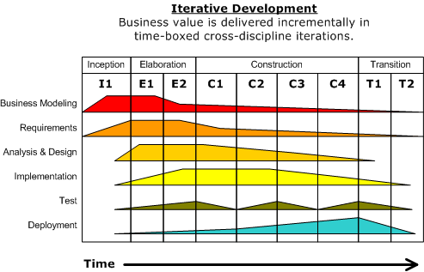

Figure 17 - Unified process and its phases

In the end, the implementation follows all the plans, furthermore all the code is organized in a logical way, so it should be quite easy to understand any part of the system with the provided documentation. All the files were categorized, providing an easy way to see the logical structure of the project.

To conclude, the group achieved the goal and carried out a development process that resulted in a functional system.

# Project future

## Target group

The final product is a game and therefore could be put in any platform that has section for VR products. Its purposes are both entertainment and learning, which increases the potential target group. On one hand, it is an escape room game but on the other, it give an immersive experience of a few disorders.

When talking about the technology, it should not be any hard for most people to get used to the controls and, what is more important, the player has a possibility to try again until they succeed doing any in-game action. That is why it could be said that “Other Perspective” is also a good place to get in touch with VR for the first time due to its user- friendliness.

Taking all the things into account, one of potential uses could be setting up all the VR equipment in a place like a museum or a medical place that is related in some way with disorders that are simulated in the game and letting the guests/patients to try it out. It would be possible thanks to the way everything is arranged, as the puzzles can be completed separately.

## Future development

As it is with most systems, there are many possibilities for future development and additional features. It is no different with “Other Perspective”. Due to the fact that all the puzzles are basically independent elements that are put together, adding new ones is an extremely easy thing to do. The scene itself could be extended with additional rooms and any needed objects could be added.

Besides adding new puzzles, the game story could be continued as well. The thing that has been created so far would be only the first chapter of a much longer and more developed thing. For instance, the whole building could have more levels and the one that is a whole scene right now would be only a tutorial level.

When it comes to simulated disorders, there is no reason not to add new ones. As mentioned in previous chapters of the report, there were many other ideas, that were dropped at some point of developing the project. New puzzles could make use of, for example, schizophrenia or phobias in some way.

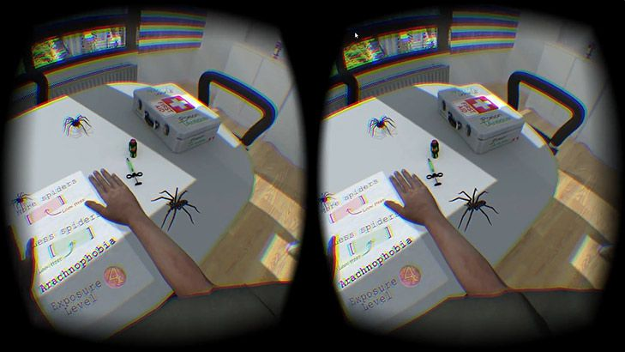

Figure 18 - Phobias - one of potential disorders to be added

Most of the things mentioned above would require quite a lot of work but the product that has been developed is designed in a way that allows to make future extensions without changing too much in the current version.

# Sources of information

*Colour-blindness awareness (no date)* Available at: http://www.colourblindawareness.org/colour-blindness/types-of-colour-blindness/ [Accessed 8 June , 2019].

*Facts about colour-blindness (no date)* Available at: https://nei.nih.gov/health/color_blindness/facts_about [Accessed 8 June , 2019].

*What is Parkinson's? (no date)* Available at:

https://parkinson.org/Understanding-Parkinsons/What-is-Parkinsons/Types-of-Parkinsonisms [Accessed 8 June , 2019].

*Types of Parkinson's and parkinsonism (no date)* Available at:

https://www.epda.eu.com/about-parkinsons/types/progressive-supranuclear-palsy-psp/ [Accessed 8 June , 2019].

*Oculus Rift vs HTC Vive: which is the better headset? (no date)* Available at:

https://dgit.com/oculus-rift-vs-htc-vive-61022/ [Accessed 8 June, 2019]

*Can Virtual Reality Change Your Mind? | Thong Nguyen | TEDxMinneapolis (no date)* Available at:

https://www.youtube.com/watch?v=eFHj8OVC1_s&fbclid=IwAR2D5lCkS7Up1mBXoQzdzQ6lWqZR3X_kvDCO4jcMcWS6BGDrzNa6iwrcP5g [Accessed 8 June , 2019]

*Breaking Into the Boom in Escape Rooms: What Entrepreneurs Need to Know (no date)* Available at:

https://www.nytimes.com/2018/04/11/business/escape-room-small-business.html [Accessed 8 June , 2019]

*Top 5 VR Escape Room Games (no date)* Available at:

https://www.wearvr.com/collections/escape-rooms [Accessed 8 June , 2019]

*Microsoft HoloLens Development Edition (no date)* Available at:

https://www.microsoft.com/en-us/p/microsoft-hololens-development-edition/8xf18pqz17ts?activetab=pivot:techspecstab [Accessed 8 June , 2019]

*HoloLens' worst enemy is still itself (no date)* Available at:

https://mashable.com/2018/05/08/microsoft-hololens-field-of-view-big-weakness/?europe=true [Accessed 8 June , 2019]

*WHAT IS HIGH-END VIRTUAL REALITY? (no date)* Available at:

https://www.vive.com/us/comparison/ [Accessed 8 June , 2019]

*Vores mest avancerede gaming-headset til pc (no date)* Available at:

https://www.oculus.com/rift-s/ [Accessed 8 June , 2019]

*Oculus Rift vs HTC Vive: Which is the Better Headset? (no date)* Available at:

https://dgit.com/oculus-rift-vs-htc-vive-61022/ [Accessed 8 June , 2019]

*SteamVR Plugin (no date)* Available at:

https://assetstore.unity.com/packages/tools/integration/steamvr-plugin-32647 [Accessed 8 June , 2019]

# Appendices

Appendix A – Use case diagram

Appendix B – Activity diagram

Appendix C – Questionnaire